Exposition/Adoration/Mass

Altar is set with four candles and a white cloth. (Two candles if the Blessed Sacrament is in a ciborium rather than a monstrance.)

- Fr. N. in humeral veil, with the monstrance; server carrying incense, enter and place monstrance on altar.
- Hymn begins:

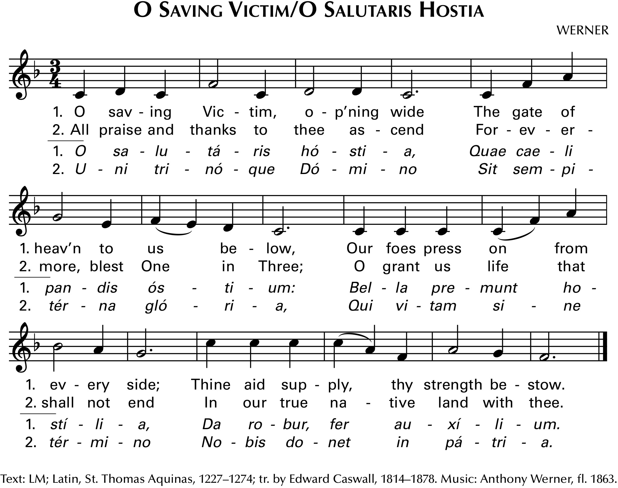

II. Exposition/Adoration

- At the altar, presider will set the monstrance on the altar.
- Server with incense will hold the censor out to the leader.
- Presider kneels and incenses the Blessed Sacrament.

- Reading with two-minute talk (this is optional)
- Silent Adoration (30-40 minutes)
- Litany of the Eucharist (this is optional and/or can be replaced with a different litany)

Lord, have mercy Lord, have mercy
Christ, have mercy Christ, have mercy
Lord, have mercy Lord, have mercy
Jesus, the Most High have mercy on us
Jesus, the holy One have mercy on us
Jesus, Word of God have mercy on us
Jesus, only Son of the Father have mercy on us
Jesus, Son of Mary have mercy on us
Jesus, crucified for us have mercy on us
Jesus, risen from the dead have mercy on us
Jesus, reigning in glory have mercy on us
Jesus, coming in glory have mercy on us
Jesus, our Lord have mercy on us
Jesus, our hope have mercy on us
Jesus, our peace have mercy on us
Jesus, our Savior have mercy on us
Jesus, our salvation have mercy on us
Jesus, our resurrection have mercy on us
Jesus, Judge of all have mercy on us
Jesus, Lord of the Church have mercy on us
Jesus, Lord of creation have mercy on us
Jesus, Lover of all have mercy on us
Jesus, life of the world have mercy on us
Jesus, freedom for the imprisoned have mercy on us
Jesus, joy of the sorrowing have mercy on us
Jesus, giver of the Spirit have mercy on us
Jesus, giver of good gifts have mercy on us
Jesus, source of new life have mercy on us
Jesus, Lord of life have mercy on us
Jesus, eternal high priest have mercy on us
Jesus, priest and victim have mercy on us
Jesus, true Shepherd have mercy on us
Jesus, true Light have mercy on us
Jesus, bread of heaven have mercy on us
Jesus, bread of life have mercy on us
Jesus, bread of thanksgiving have mercy on us
Jesus, life-giving bread have mercy on us
Jesus, holy manna have mercy on us
Jesus, new covenant have mercy on us
Jesus, food for everlasting life have mercy on us
Jesus, food for our journey have mercy on us
Jesus, holy banquet have mercy on us
Jesus, true sacrifice have mercy on us
Jesus, perfect sacrifice have mercy on us
Jesus, eternal sacrifice have mercy on us
Jesus, divine Victim have mercy on us
Jesus, Mediator of the new covenant have mercy on us
Jesus, mystery of the altar have mercy on us
Jesus, medicine of immortality have mercy on us
Jesus, pledge of eternal glory have mercy on us
Jesus, Lamb of God, you take away
the sins of the world have mercy on us
Jesus, Bearer of our sins, you take away
the sins of the world have mercy on us
Jesus, Redeemer of the world, you take away
the sins of the world have mercy on us
Christ, hear us Christ, hear us
Christ, graciously hear us Christ, graciously hear us
Lord Jesus, hear our prayer Lord Jesus, hear our prayer.

Let us pray:
Lord our God, in this great sacrament
we come into the presence of Jesus Christ, your Son,
born of the Virgin Mary and crucified for our salvation.
May we who declare our faith in this fountain of love
and mercy drink from it the water of everlasting life.

IV. Benediction

- After the litany, Presider will go to the altar, genuflect, and kneel.
- The gathered sing “Tantum Ergo,” as the presider, kneeling, incense the Blessed Sacrament:

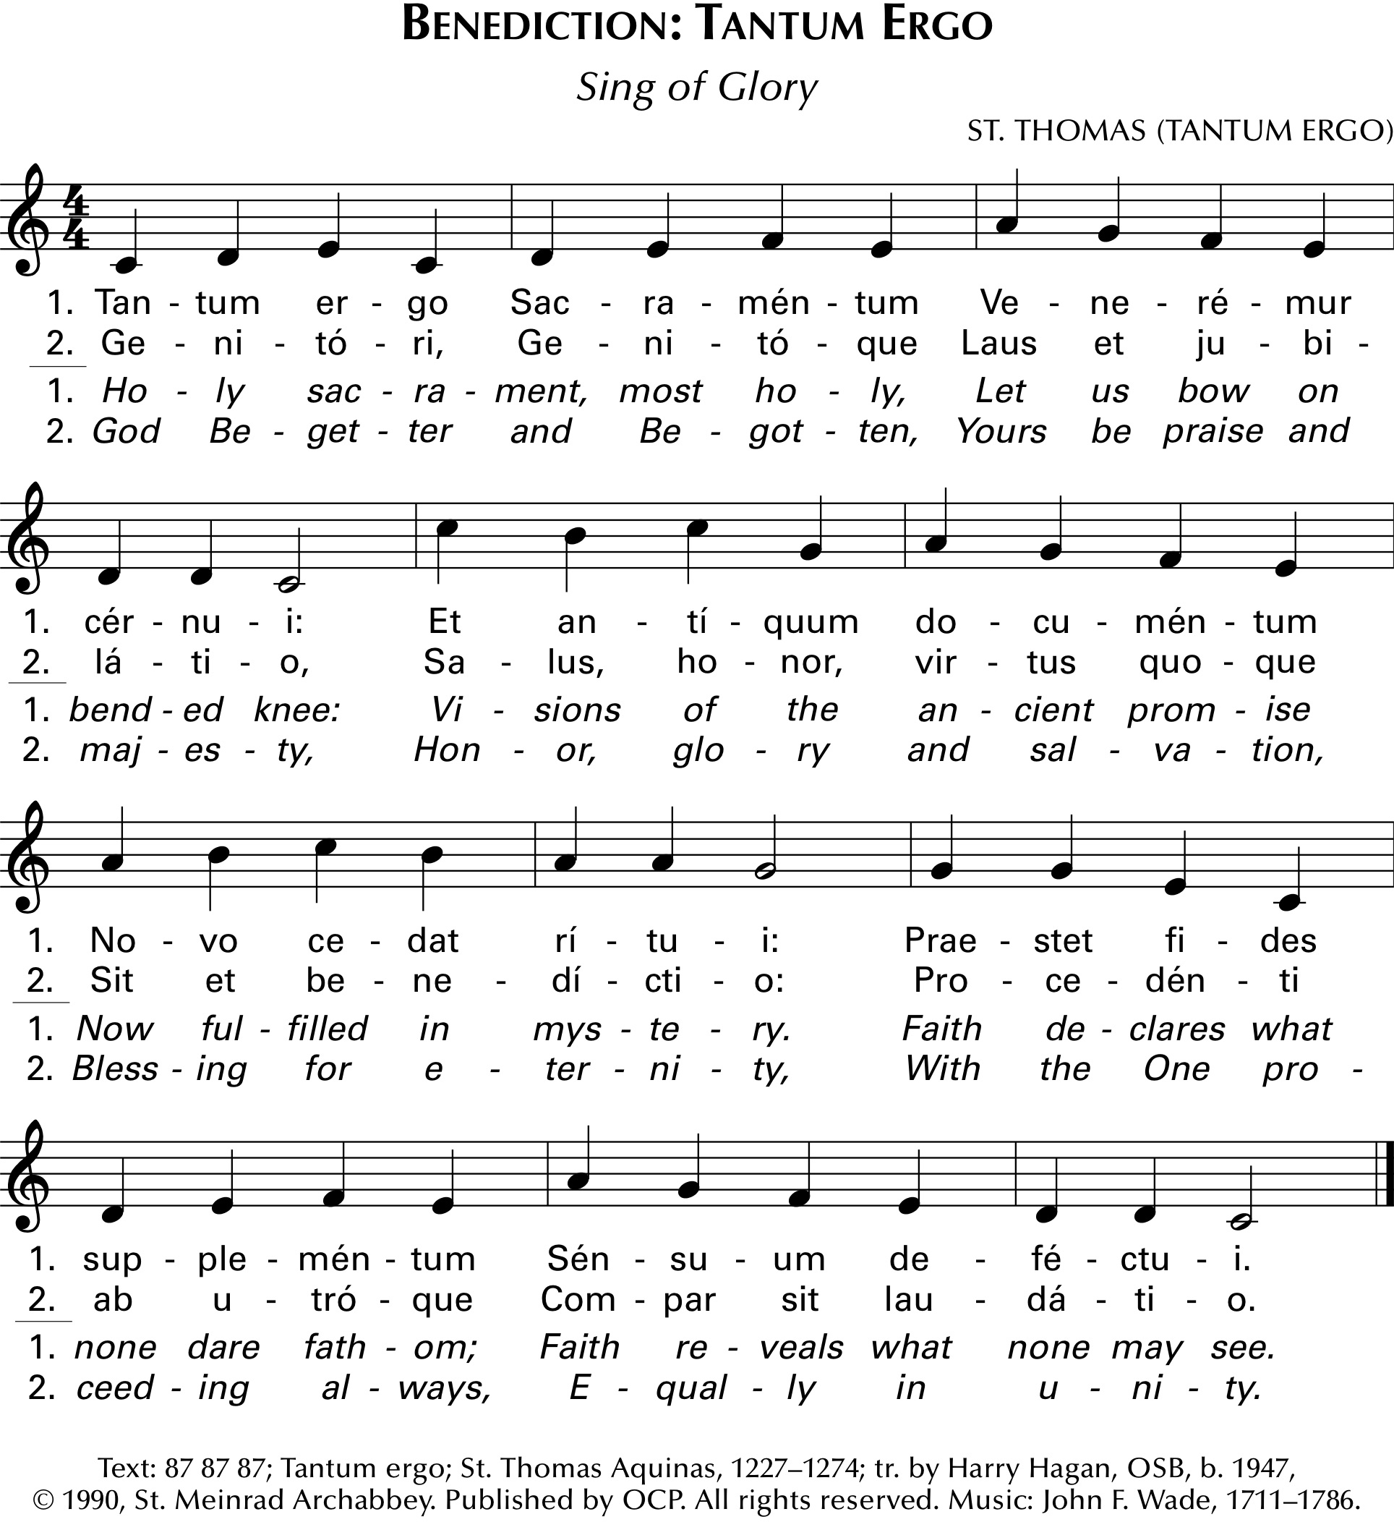

- After this, and after the “Tantum Ergo” is finished, the presider will rise for the following (or another prayer; see Holy Communion and Worship of the Eucharist Outside Mass):

Fr. N:

Let us pray.

Lord our God,
teach us to cherish in our hearts
the Paschal Mystery of your Son
by which you redeemed the world.
Watch over the gifts of grace
your love has given us
and bring them to fulfillment
in the glory of heaven.
We ask this through Christ, our Lord. R: Amen.*
- The presider, in humeral veil, goes to the Blessed Sacrament, genuflects, and takes the monstrance.
- Facing the people he makes the sign of the cross over them with the monstrance, in silence.
- The Divine Praises follow.
- The Blessed Sacrament is taken back to the tabernacle, preceded in procession (if the procession is some distance) by server with incense and servers with the candles.
- “Holy God, We Praise Thy Name” or another hymn may be sung.

*For other prayers, readings, etc., see the ritual book, Holy Communion and Worship of the Eucharist Outside Mass, beginning on page 66.

